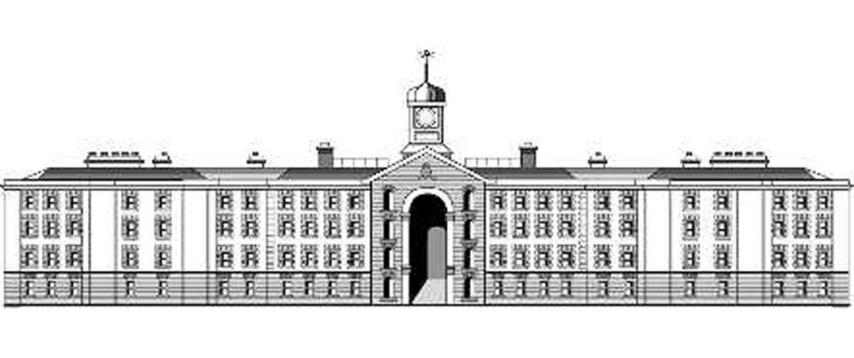
Griffith College Dublin International Office
Scholarship Application Form
Part A: To be completed by student
1. Personal Details
Family Name:
Given Name:
Date of Birth: |  |  | Country of Origin:
GCD No: |  |  |  | Course: |  |  |  |  |  | Year:
2. Previous Academic Performance

Mark Sheets
Please provide copies of your original mark sheets for the past academic year. If this is your first year at GCD please provide copies of your mark sheets for the last academic year spent in a different Secondary or Third-level educational institution.

Personal Statement of Purpose

On a separate sheet please attach a typed submission explaining your reasons

for requesting a Scholarship from Griffith College Dublin.

Part B: To be completed by International Office
Attendance Rate: |  |  |  |  |  | Academic information verified as being correct: |  | Yes No
Course Fees:
Scholarship Amount :
Fees Due:
Payment schedule:  Minimum of 50% of tuition fee to be paid at time of first instalment. |  |  | 1st Instalment: €_________ due by ___/___/___  Final Instalment: €_________ due by ___/___/___
Part C: To be completed by Student Fees Office
Credit Controller  Recommendation: |  |  |  |  | Approve Refuse
If Refused: Reason
for Refusal
Signed: _______________________________________ ______________
Credit Controller Date

Part D: To be signed after decision has been made
I am satisfied with the fees as indicated above and I agree to adhere to the above schedule of payments. I understand that if I fail to adhere to the above schedule, I may not be permitted to sit any further examinations in the College and my place in the College may be withdrawn.

Signature (Student): |  |  |  |  |  |  |  |  | Date:
Signed (International Office): |  |  |  |  |  |  |  |  | Date:
Signed (Student Fee Office): |  |  |  |  |  |  |  |  | Date:

